**COS10004 – Computer Systems**

**Name: Nguyen Manh Dung**

**Student ID: SWH01226**

                                     Assignment 1

Description of my Assignment 1 circuit

The logic circuit is basically a digital music player with the ability to count tracks, play/pause music, and adjust volume. The logic circuit uses various components which are gates, flipflop, buffer, hex display and splitter.

Design Outline

To build up a music player, I have separated it into 3 small part that have an individual function.

Firstly, on the top of the circuit is the On/Off button, and this button makes sure that all the led lights in the circuit are turned off when the music player is in the OFF state. They are also linked to the HEX digits display to make sure that it is likewise turned off when the player is in the Off state.

Additionally, there are two separate Play and Pause buttons and two separate Play and Pause LEDs:

When the PLAY button is set to on, the system enters the PLAY state:

- The Play LED is turned on

- The Pause LED is turned off.

When the PAUSE button is set to on, the system enters the PAUSED state:

- The Play LED is turned off

- The Pause LED is turned on.

When clicked the Play button:

                -The Pause LED has no effect on

When clicked the Pause button:

                -The Play Led is set to on, means that we unpause the circuit

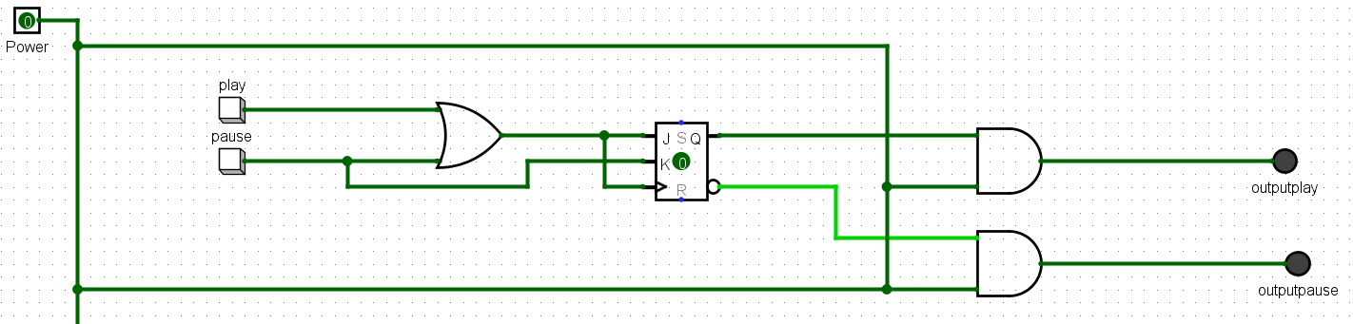  
In the Play/Pause function, I used 1 OR gate, 2 AND gate and a JK FlipFlop, these things are used to Play/Pause the song.

Next, the Volume+ and Volume- buttons are used to increase and decrease the volume of music. This function uses a very basic circuit called stacks (which we have learned in week 4).

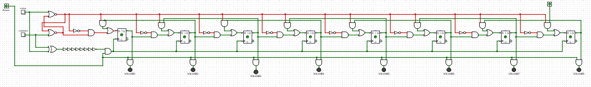

First, I used a SR FlipFlop which is used for storing the bit, then I put 8 Bit Stacks, which contain NOT gate, 2 AND gate 1 OR gate and a D FLipFLop to display the LED outputs. And in terms of clock input, I used an XOR gate combined with 8 buffers to replace the common clock.



The reason why I used XOR gate is that the truth table of XOR gate lets me control the clock and the input at the same time. 8 buffer is used to delays the counter (based on delay principles)

Source: <http://www.cburch.com/logisim/docs/2.6.0/en/guide/prop/delays.html>

A buffer stands for 1 bit, and there are 8 buffers in this function. Additionally, I put an AND gate in every LED output and clock output to make sure that the circuit runs only when the power button is on.

Finally, the trackcounter circuit. Basically I used 2 bidirectional counter with JK FlipFlop.

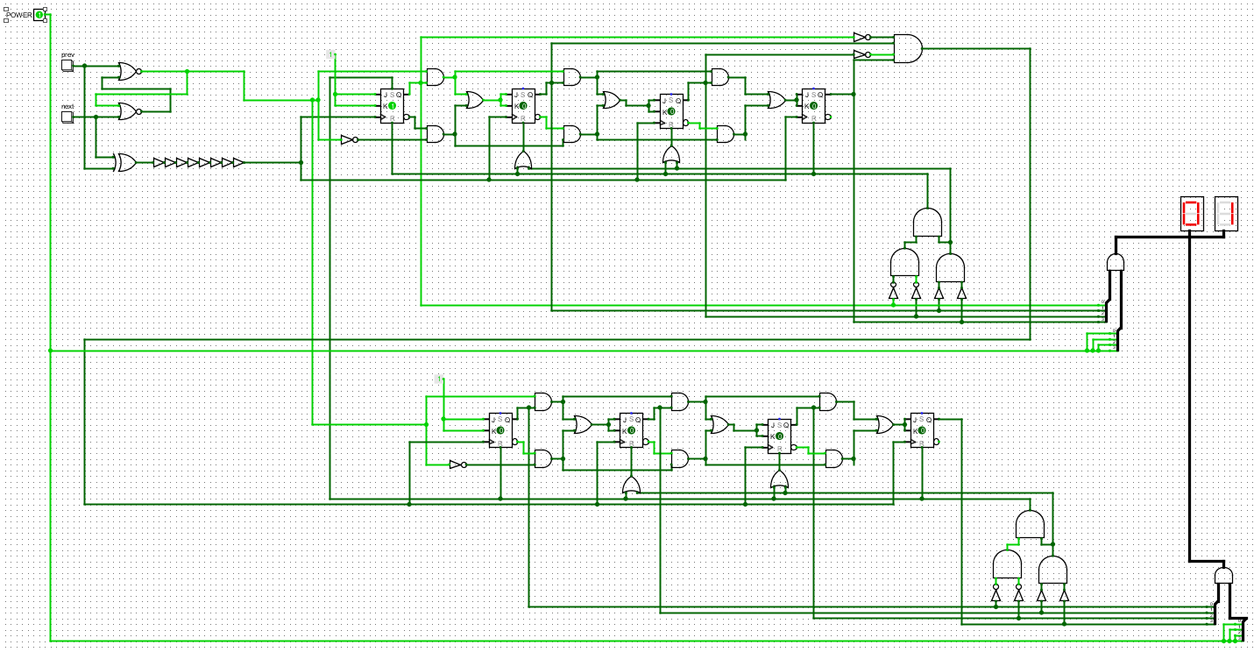

The reason why I used 4-bit bidirectional counter is that the 4-Bit counter advances upward in sequence (0,1,2,3,4,5,6,7,8,9) or downwards in reverse sequence (9,8,7,6,5,4,3,2,1,0), this sequence only happened when we reset is because 4 bit counter can count up to F. So, I built a reset circuit which have 3 AND gate 2 NOT gate and buffer. To skip all the numbers from A-F, I have to build 2 different reset circuits. The first one is to reset A (1010) and the second one is to reset F(1111). To reset A (1010) I used the output of AND gate which is plugged from 2nd bit output and 4th but output then plugged to all FlipFlop in order to return to 1001 is 9. To reset F (1111) I have to use combination of 3 AND gate to check the 2nd and 3rd FlipFlop, the reason why I put 2 buffer here is that because if there is no buffer gate it will take the output of the other and the other gate first and will mistakenly match the output of not gate. And to update from units to tens, I had to design a circuit so that when from 9 (1001) it will be set to 1(0001) in tens and so on in sequence. Finally, to reset the counter from 99->01 I link the reset circuit (the one that reset all the counter) into Set input in order to skip the number 0

Assumption

During this project, I have tried to build up the circuit without any assumption. All the logic in this can be found in the previous lectures. I created a combination to reset the trackcounter based on the gate truth table.

**Unsolved Problem**

I can not think a solution to reset 01 back to 99

**Screenshot of my circuit**

